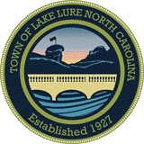
TOWN OF LAKE LURE
Town Council Special Meeting
Friday, February 27, 2026 – 2:00 p.m. Town Hall at the Landings

Agenda

- Call to Order

- Consider Termination of the Memorandum of Understanding with William C. Morgan, Jr. and the Attorney-Client Relationship

- Consider Adoption of Resolution No. 26-02-27 Approving Engagement Agreement with Allen Stahl + Kilbourne and Appointing Allen Stahl + Kilbourne as Town Attorney

- Closed Session in Accordance with G.S. 143-318.11 (a) (3) for Attorney-Client Privilege

- Adjournment

